**Create locally remote repo like tfs collection**

Install git

**Set Up a Local Network Repository**

If you want to simulate a remote repository, you can create a bare repository on your local network or even on your local filesystem. Here’s how you can do that:

**1. Create a Bare Repository:**

1. Open a command prompt or terminal.

2. Navigate to the location where you want to create your bare repository.

3. Run the following commands:

mkdir my-repo.git

cd my-repo.git

git init –bare

**2. Add a Remote Reference:**

On your working directory (the repository where you’re doing your actual work), add this bare repository as a remote:

git remote add origin /path/to/my-repo.git

See Sample screen shots

I will use below folder

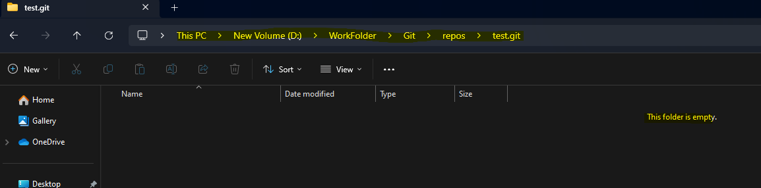

I skip first 2 commands because I already created the folder just I use 3rd command only inside that folder

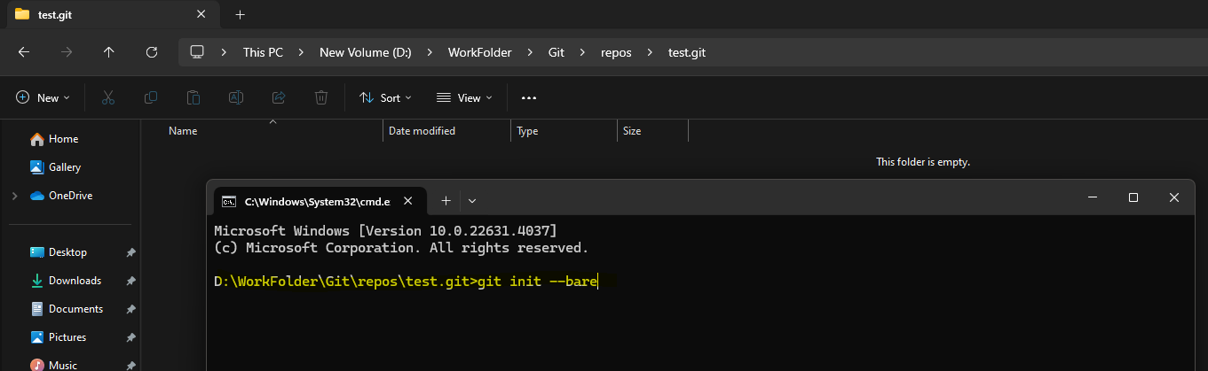

Hit enter

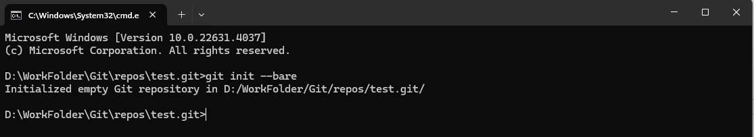

Now we see the below files on that folder, we can do this in local server also here I choose client pc local machine

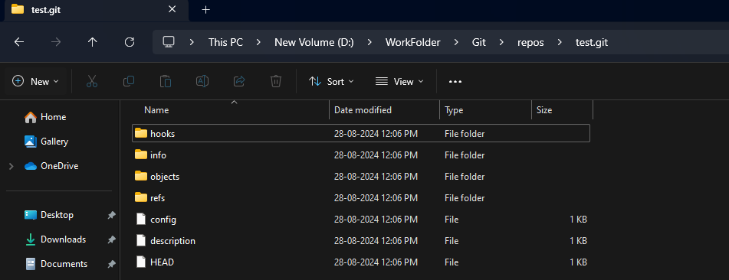

Now add remote reference (optional step we can proceed without this)

git remote add origin /path/to/my-repo.git

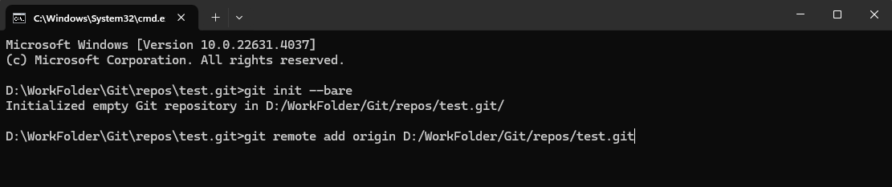

Hit enter that’s all.

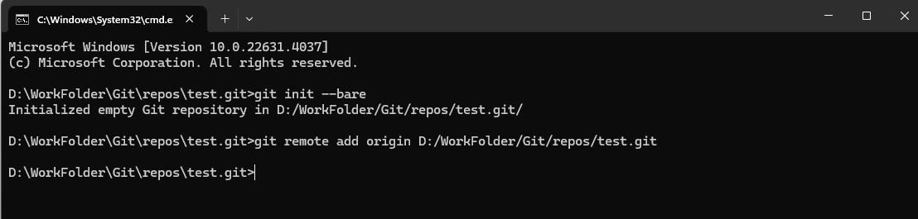

Now add existing project to the git repos

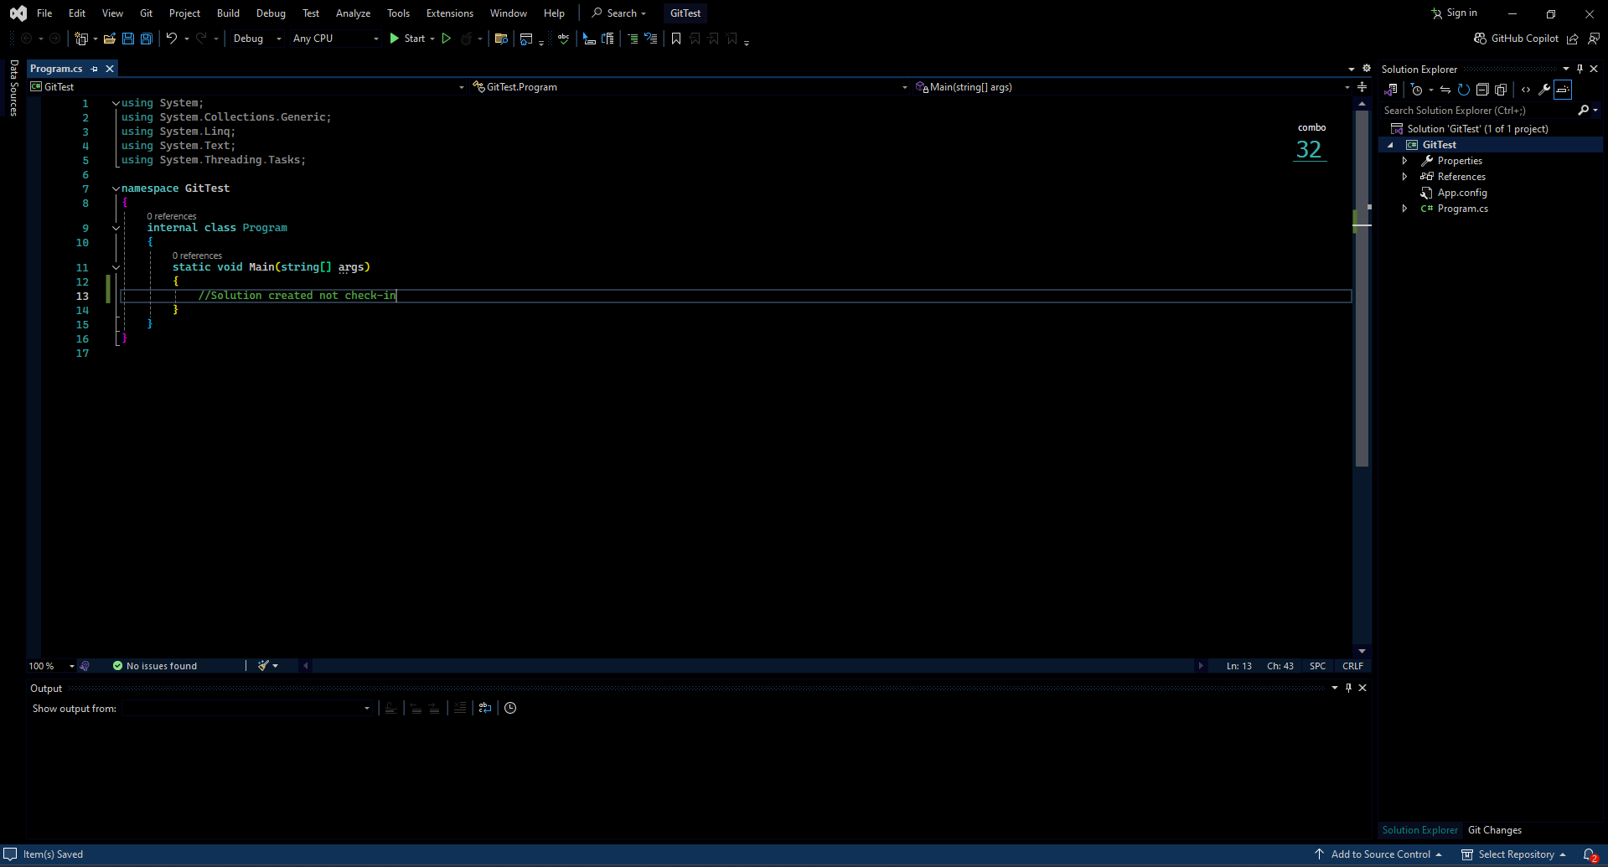

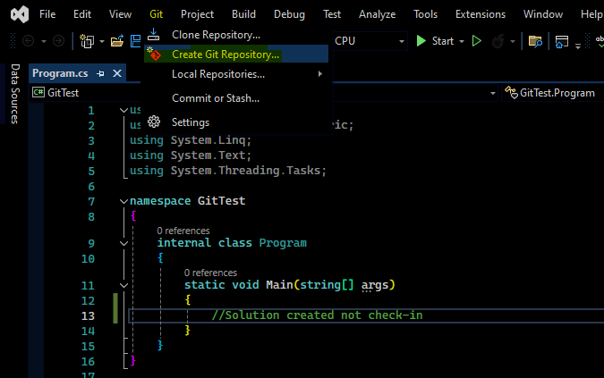

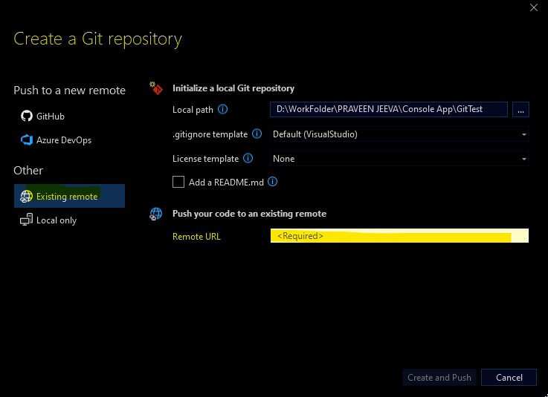

Now paste local remote repo path 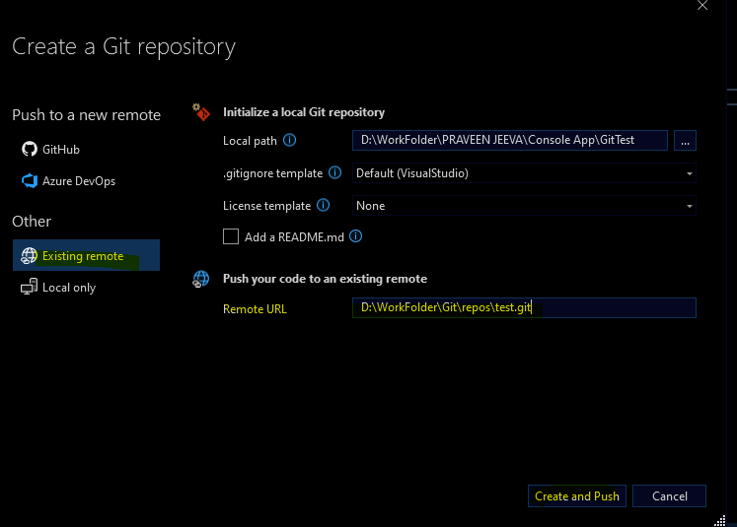

Hit Create and Push button

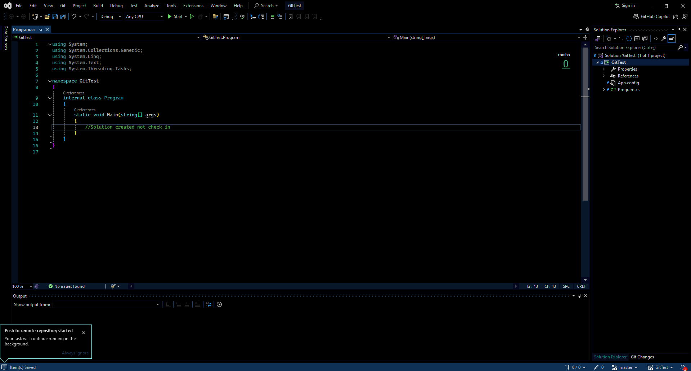

That’s it.

You can also use a network path if the repository is on a shared network drive (e.g., \\network\path\to\my-bare-repo.git).

Now see how clone the solution from local bare file (Like tfs download option)

Open visual studio

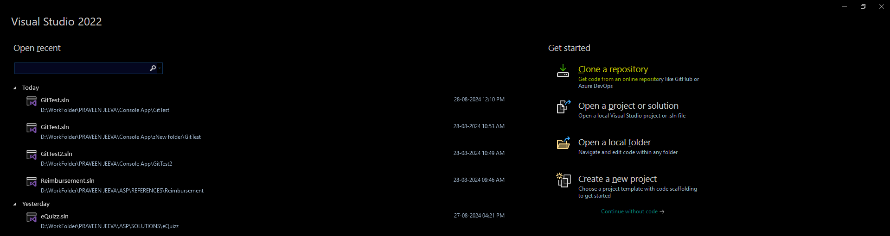

Now choose Clone a repository option

Paste local or server remote path and choose path where clone or download

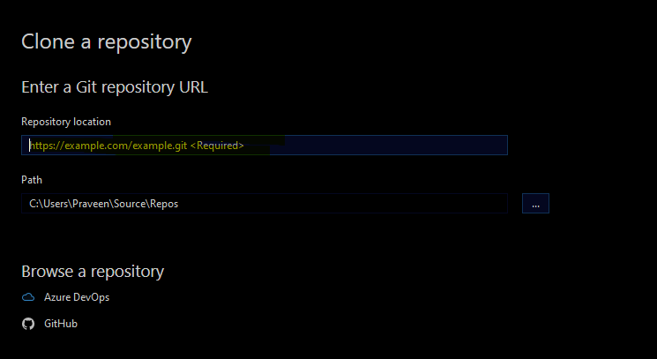

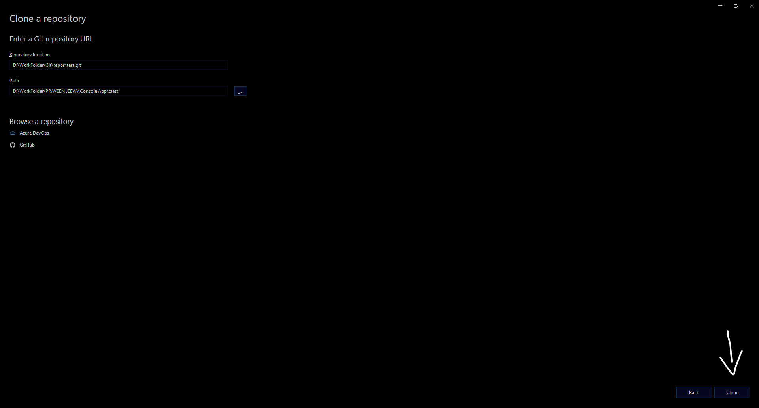

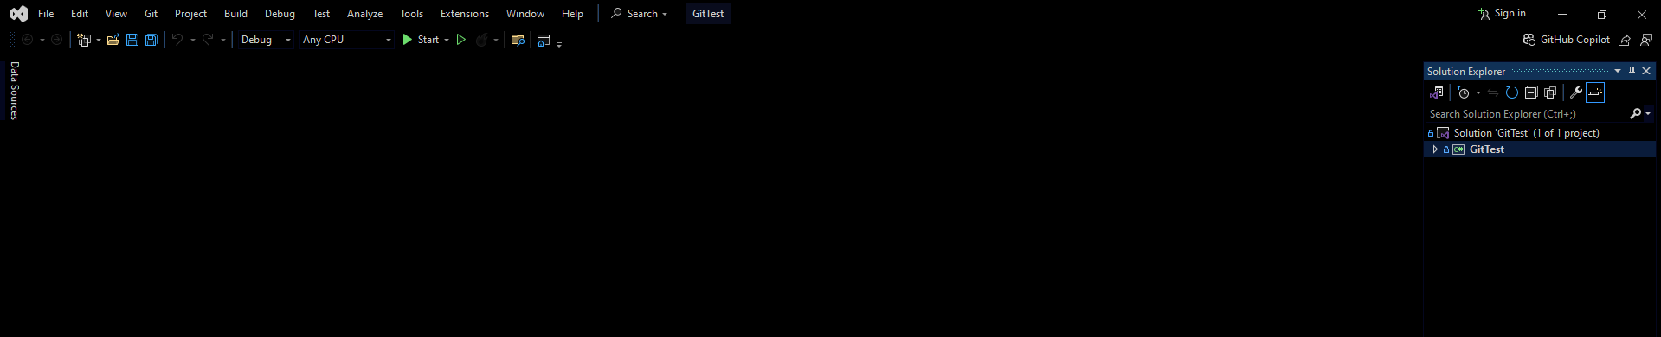

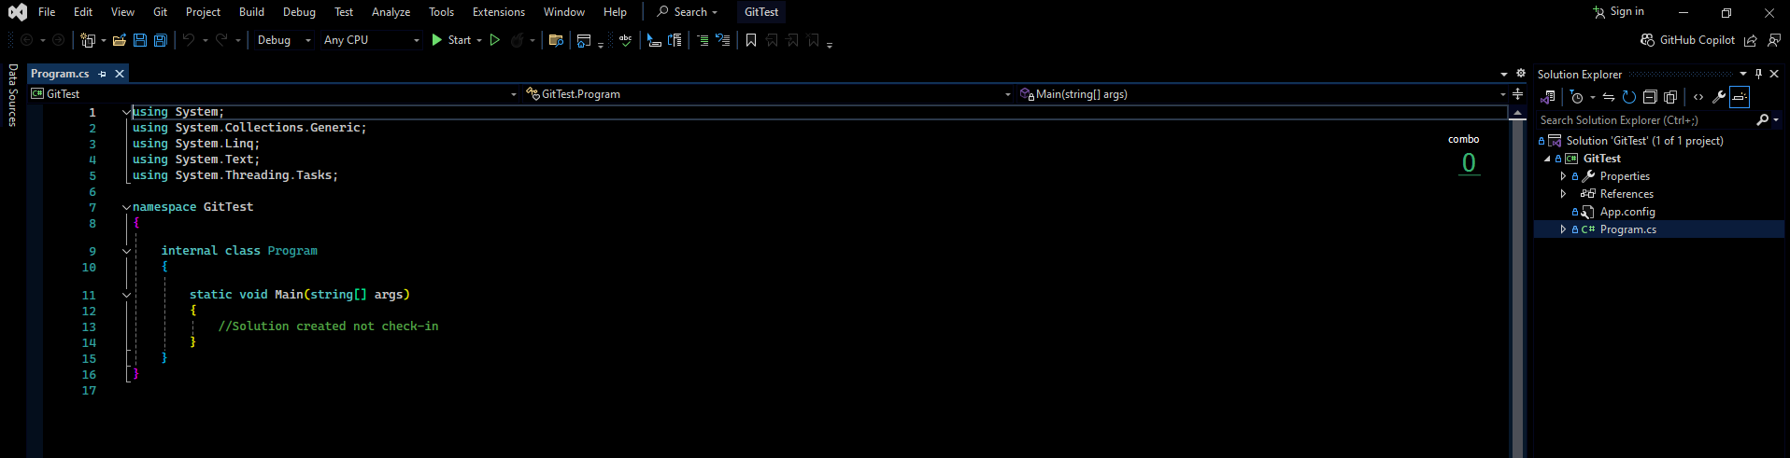

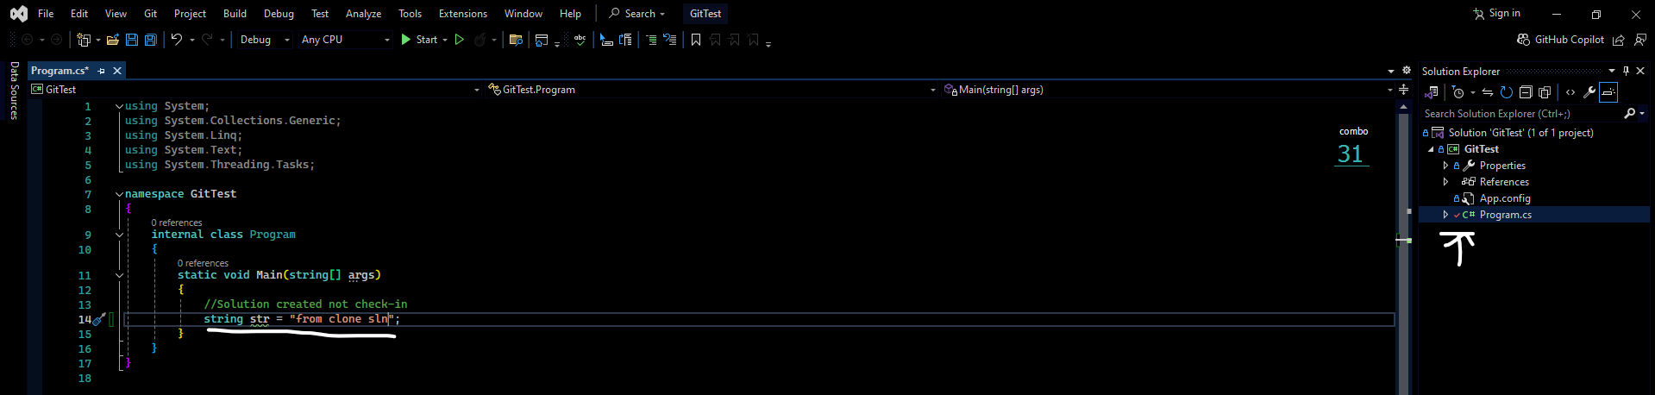

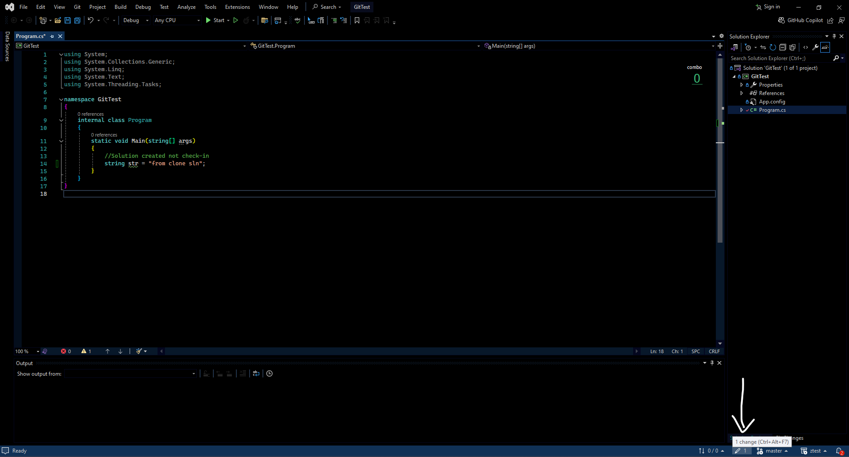

Write some code in cloned sln. And commit changes

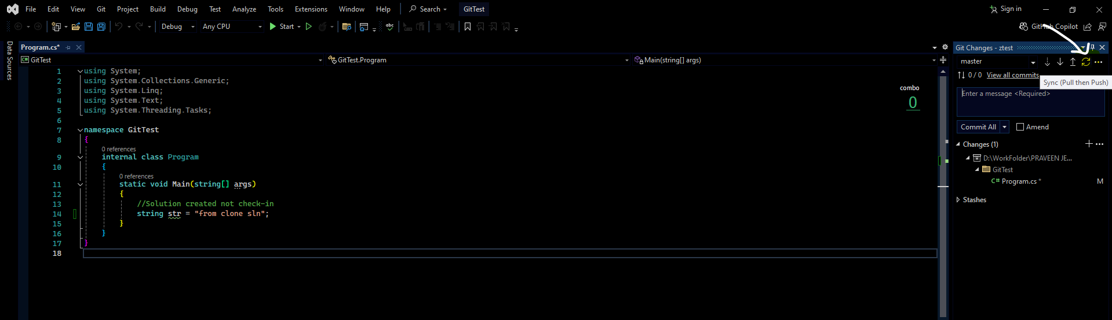

Use sync option before commit it is good practice if someone commit changes in this solution it will sync.

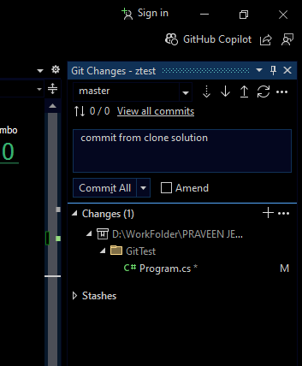

Hit commit all

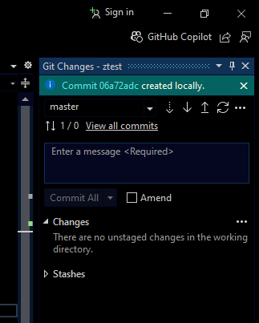

Successfully committed.

After commit use sync option

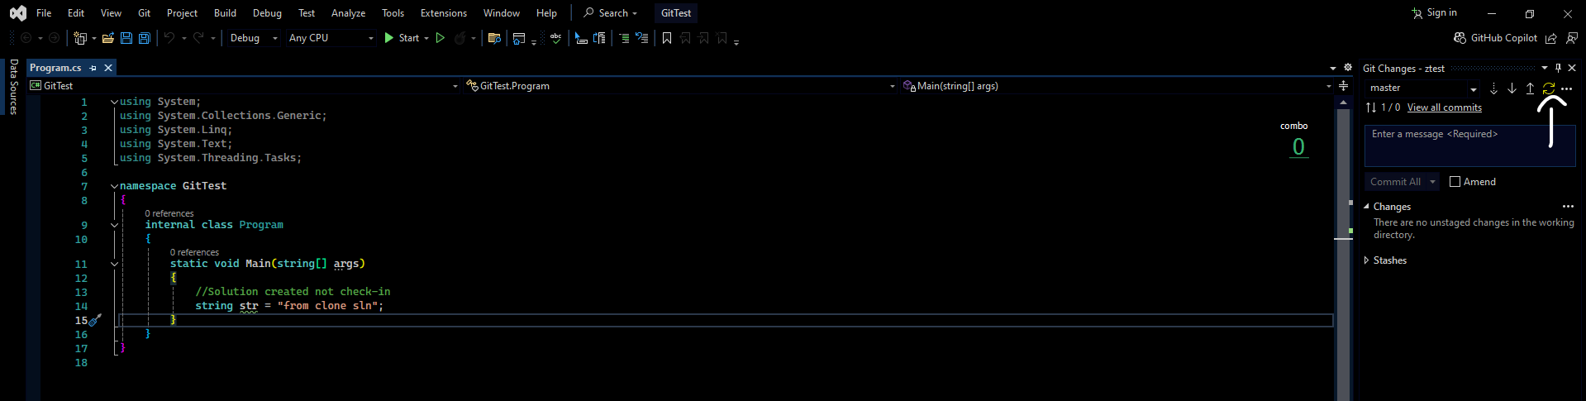

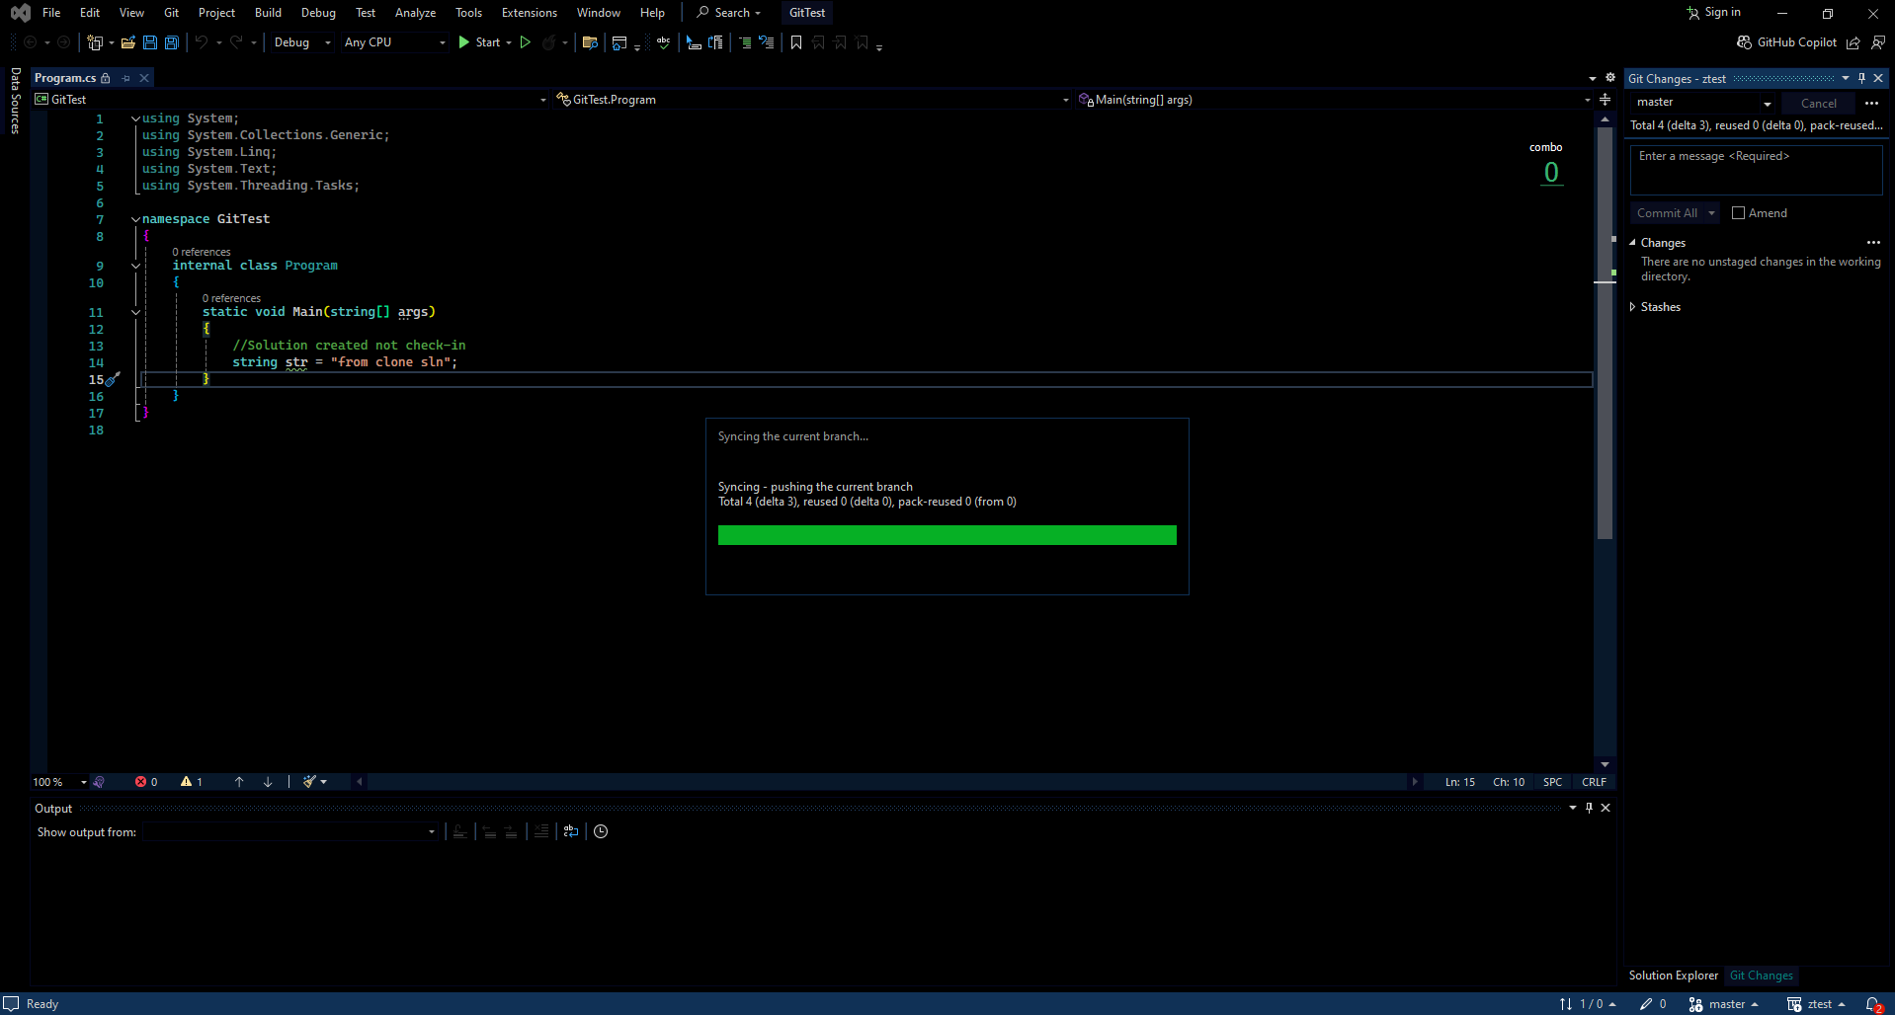

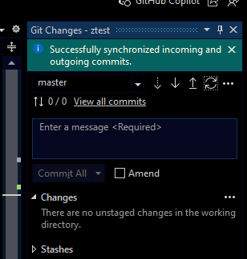

Now open actual solution which was created initial stage then we get recent changes

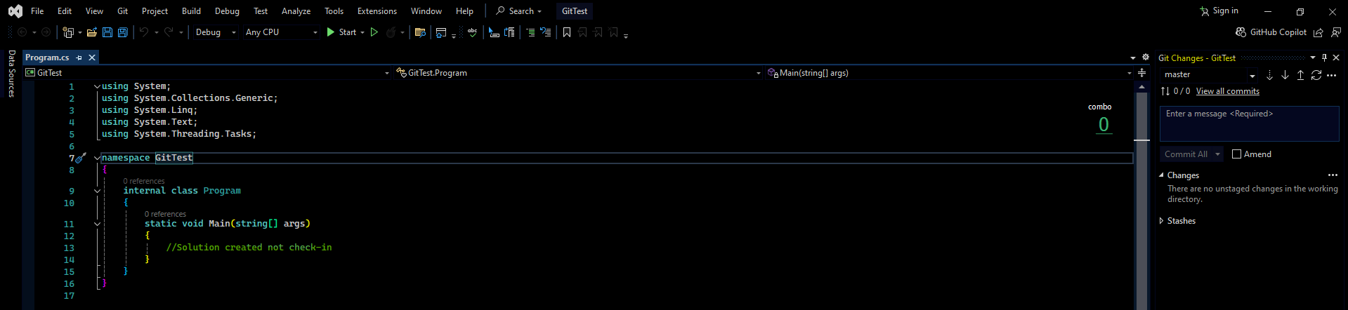

Now press sync

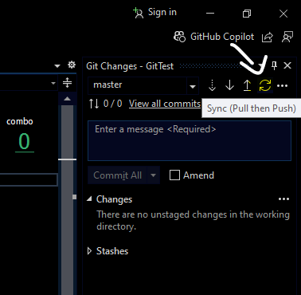

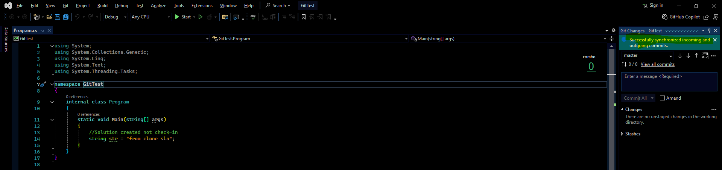

Now we get latest version, that’s it.

**Note: Each solution we need to create separate bare file**